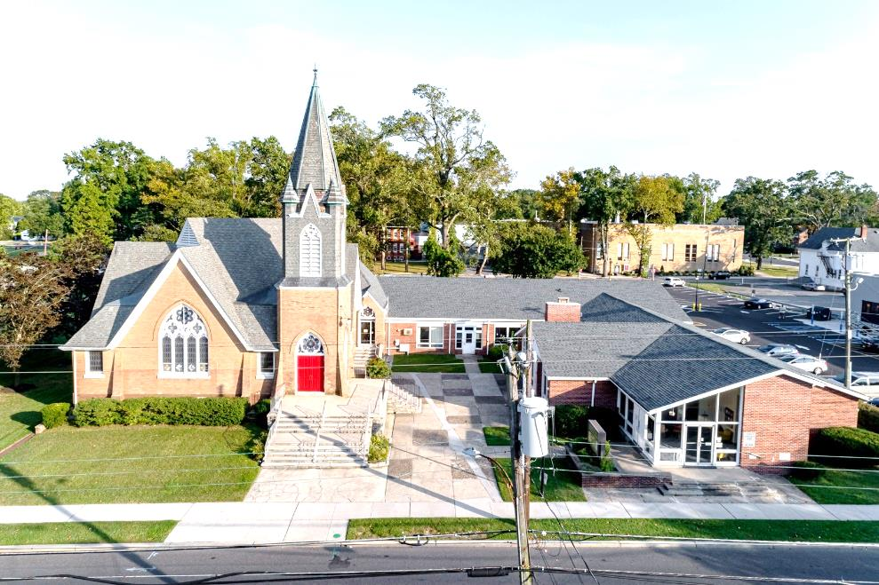

The Presbyterian Church at Hammonton
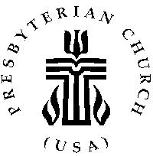

Our vision is to open our doors to all seeking a spiritual home of worship and to carry the light and love of Jesus Christ, our Savior, throughout the community.

MISSION STATEMENT
We are committed to Jesus Christ and the growing of his Church by glorifying God and by proclaiming the good news of the gospel through word and deed. We involve and reach out to our members and our community in Christ’s name through worship, Christian Education, and stewardship to support the mission of our church.

Note: Special thanks to Rev. Dr. Debby Brincivalli for leading us in worship today.

Organist: Cindy Birnbaum
Sunday School Superintendent: Beth Burkett-Rice

2022 2023 2024
ELDERS
Eric Copenhaver Robert Bauers Sallye Hershman
Marylee Kondrach Dorrine Esposito Paul Moul
Charles Muller Richard Walker Johanna Johnson

DEACONS
Elsie Bakley Wendy Copenhaver Hilda Lugo
Nancy Foster Ann DiMeo Carol Orsi
Margaret Jones Rebecca Lindstrom Rebecca Villani

Clerk of Session: Beth Burkett-Rice

Church Office: 326 Bellevue Avenue, Hammonton, NJ
Office hours: Tuesday - Thursday 9:30 AM to 12:30 PM
Phone (609) 561-0168 ~ Fax (609) 561-6105
e-mail: office@hammontonpres.org
website: www.hammontonpres.org

THE CELEBRATION OF WORSHIP
JUNE 12th, 2022
TRINITY SUNDAY
VIRTUAL & LIVE SERVICE
11:00am
****************************************************
~ GATHERING IN GOD’S NAME ~
“Welcome to the Presbyterian Church at Hammonton, we are glad you are able to join us. As we gather for worship feel free to pray and meditate on God’s calling in your life. Be respectful of others around you who might be doing the same, prior and during the Prelude, keeping your voice and conversation soft and to a minimum.”
PRELUDE ~“I Would Be True”– L. Warriner
“Called As Partners in Christ’s Service”– G. Peterson
“Firm In the Faith”– T. Kendall

~ TIME FOR CENTERING STILLNESS AND SILENCE ~

WELCOME AND ANNOUNCEMENTS

*THE PEACE
Let the people greet one another by staying in their seats and saying: “Peace be with you!”

INTROIT

~ HUMBLY APPROACHING GOD ~

OPENING PRAYER

*CALL TO WORSHIP (Adapted from Psalm 95:6-7)
One: Come, let us sing for joy to the Lord;
All: Let us shout aloud to the Rock of our salvation.
One: Let us come before God with thanksgiving
All: And extol God with music and song.
One: Come, let us worship God!
*HYMN #138~ “Holy, Holy, Holy! Lord God Almighty”

CALL TO CONFESSION

PRAYER OF CONFESSION (unison)
Loving God, remind us of the truth that every good and perfect gift comes from You. God, we admit that even in our moment of gratitude, we fall short. We feel thankful for the gifts without acknowledging the Giver. We praise the beautiful creation around us without drawing close to the Creator. We sing about our salvation without glorifying You – our Savior. Forgive us. Holy Spirit, for failing to acknowledge your presence in our lives and ministry, forgive us. God, reveal Yourself to us in every good gift, and give us eyes to see You in them. In Christ’s Name we pray. Amen
(silent confession)

ASSURANCE OF FORGIVENESS
The mercy of God is from everlasting to everlasting. As far as the east is from the west so far will God remove our transgressions from us. Friends believe the good news of the gospel.
In Jesus Christ we are forgiven.

*GLORIA PATRI

ANTHEM~ “May the Love of God Enfold You”
(Flutist- Kate Ogden)

CHILDREN’S MESSAGE

~ RECEIVING GOD’S WORD ~

PRAYER OF ILLUMINATION

SCRIPTURE READINGS Psalm 8
John 16:12-15 (NT, pg 105)

MESSAGE ~ “Pitchfork Mathematics”
- The Rev. Dr. Debby Brincivalli

~ RESPONDING TO THE WORD ~

HYMN #139~ “Come, Thou Almighty King”

*SAYING WHAT WE BELIEVE- The Apostles’ Creed pg 14

JOYS AND CONCERNS OF THE CHURCH

PASTORAL PRAYER & LORD’S PRAYER
Our Father, who art in heaven, hallowed be Thy name. Thy kingdom come, thy will be done, on earth as it is in heaven. Give us this day our daily bread; and forgive our debts as we forgive our debtors; and lead us not into temptation, but deliver us from evil. For Thine is the kingdom and the power and the glory, forever. Amen.

THE OFFERING OF OUR GIFTS AND OURSELVES

OFFERTORY ~ “Our Lord, Master of All” -R. Koury

*DOXOLOGY (#592)
Praise God, from whom all blessings flow; Praise Him, all creatures here below; Praise Him above, ye heavenly host; Praise Father, Son, and Holy Ghost. Amen.

OFFERTORY PRAYER

~ GOING IN GOD’S NAME ~

*HYMN #140~ “Holy, Holy”

*THE CHARGE AND BENEDICTION

POSTLUDE~ “Postlude in G Minor” -F. Ritter

OUR WORSHIP HAS ENDED, LET OUR SERVICE BEGIN

*Signifies stand if comfortable.

~Please note, this will be the last Sunday for the choir until September.~

Last Week’s Attendance & Offering:
Attendance: 42 people
Offering: $3,200.00
______________________________________________
CHURCH EVENTS
>>>THIS WEEK:
Monday-06/13:
9:00 AM Clothing Closet
-12:00 PM
7:30 PM ESL classes

Tuesday-06/14:
9:00 AM Clothing Closet
-12:00 PM

Wednesday-06/15:
9:00 AM Clothing Closet
-12:00 PM
7:30 PM ESL classes
______________________________________________
>>UPCOMING:
Monday-06/20:
9:00 AM Clothing Closet
-12:00 PM
7:30 PM ESL classes

Tuesday-06/21:
9:00 AM Clothing Closet
-12:00 PM

Wednesday-06/22:
9:00 AM Clothing Closet
-12:00 PM
7:30 PM ESL classes
______________________________________________
BIRTHDAYS:

June 18th Dave Ordille
______________________________________________
ANNIVERSARIES:

June 12th Chris & Loretta Rehmann
June 16th Bob & Linda Rebek
June 16th Nelson & Johanna Johnson

SERVING YOU TODAY:

Liturgist: Betsy Mazzone

Ushers: Richard Walker, Captain
Richard Gibson
Ruth Gibson
Bob Rebek
Millie Walker

**Children’s Church Donna Brown
Next week: No Children’s Church

